# CYBERSECURITY THREAT INTELLIGENCE (CTI) DASHBOARD TUTORIAL

# Table of Contents

Load Data 1

Create a line graph 3

Add Filter 3

Create a Pivot Table 4

Text based graphs 5

Create Dashboard 5

# 

# Load Data

* Loading data requires ‘connecting’ to the data source. In our case, we will be loading data in file therefore we will *connect to a file*.
* Our data file is “Exploit Types Over Time.csv” which is considered as a “Text File”
* Click on *Text File* and browse to select the file in your computer

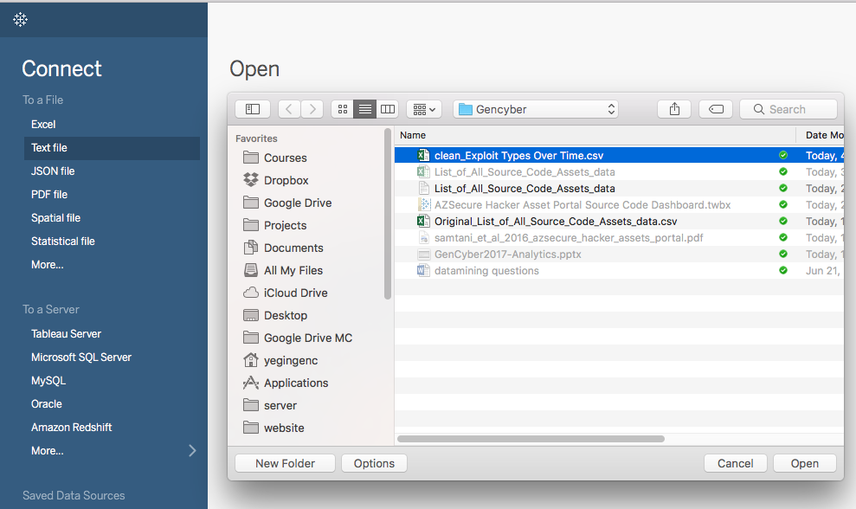

* Once connected, columns (variables) will appear on screen. Click on Update now, to import the data

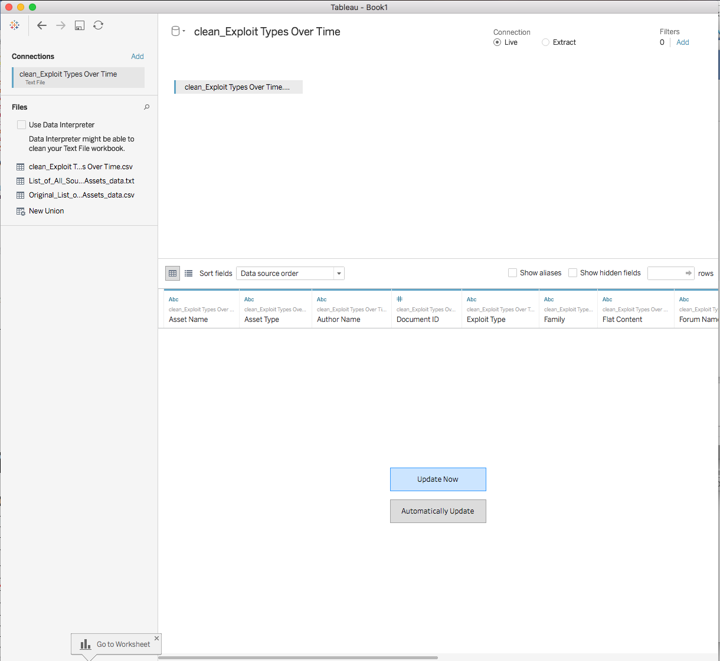

# Create a line graph

* The goal is to create a line graph that shows the number of exploits over the years broken down by the exploit type
* Select and drag the ‘*Postdatetime’* variable to Columns area.
* Select and drag the *‘Number of Records’* measure under Rows area.
* To group exploits by the *Exploit Type*, drag ‘*Exploit Type’* dimension under marks on Color.
* Bonus: Drag the ‘*Number of Records’* measure under Marks on Size. Can you tell what it does?

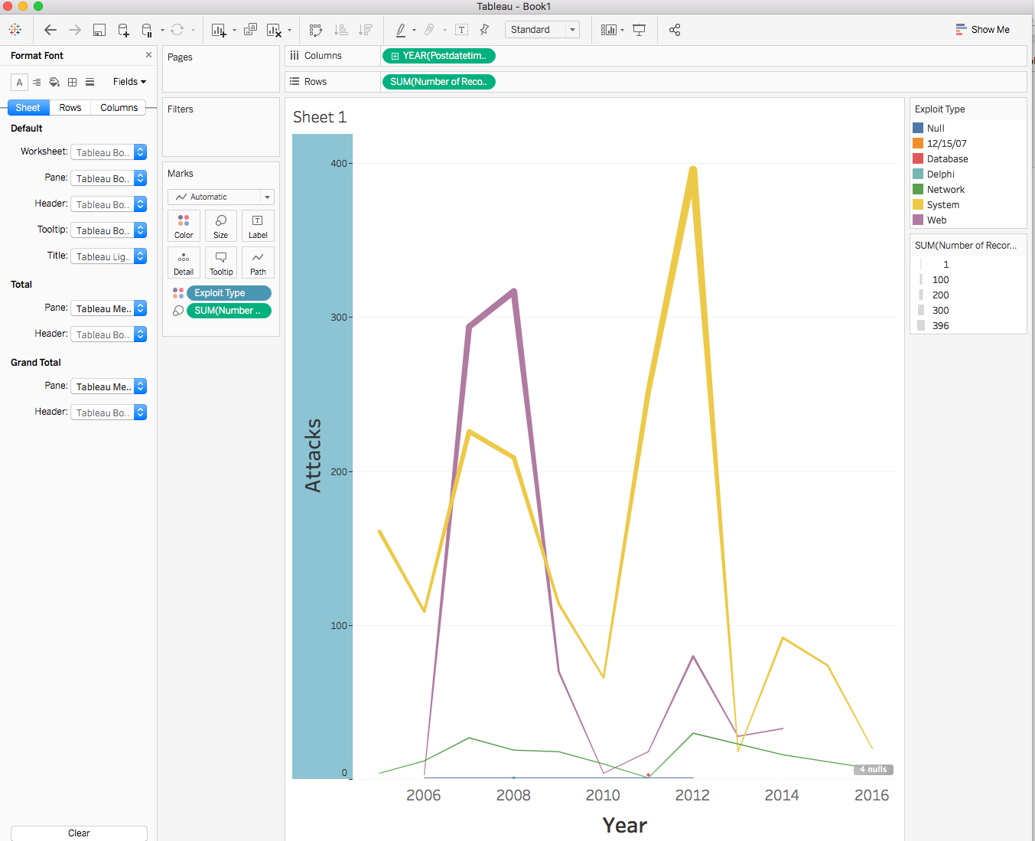

# Add Filter

* Filters allow to focus on certain observation and ignore the others. Drilling into the data can help make sense of different aspects of the phenomenon being analyzed.
* The goal is to create a filter that will allow us to focus on only certain Exploit Types in the view created in the previous section.
* Select and drag the *Exploit Type* under Filters section.
* Select an Exploit Type in the pop up menu and click ok.
* You can edit filter by right clicking on *Exploit Type* and update the selections in the popup menu.
* To make filtering more dynamic, you can right click on *Exploit Type* and select Show Filter. This should create a check box menu on the right side for ad hoc filtering.
* 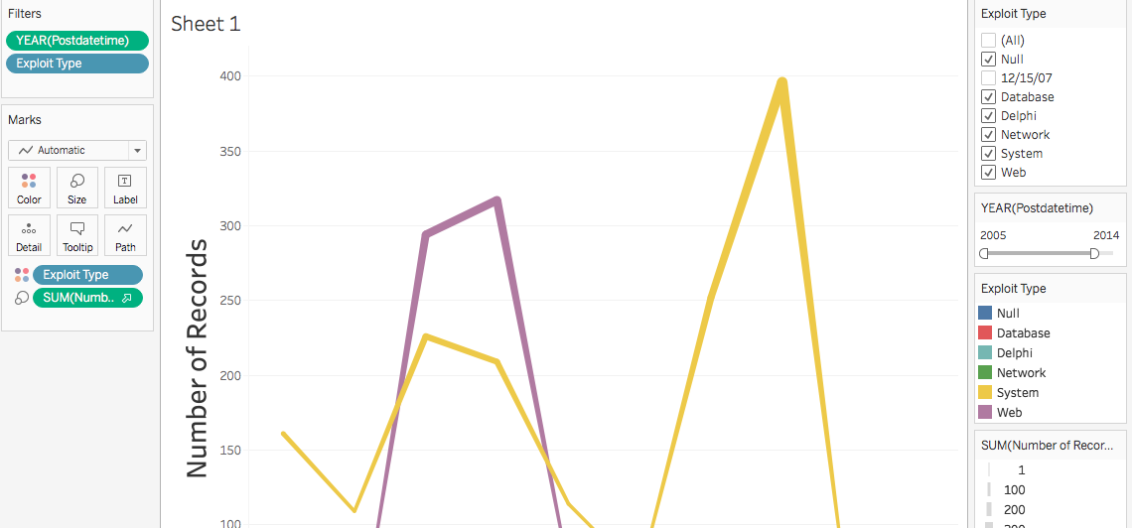Just like for the *Exploit Type*, create another filter for the year of Postdatetime - YEAR(Postdatetime). Once you are done, you should see a checkbox menu on the right side of the screen for selecting YEAR(Postdatetime).
* Right click on YEAR(Postdatetime) under Filters and select the **second** *Year* option in the right click menu.
* Click OK in the pop up menu. At this point the checkbox menu for selecting YEAR(Postdatetime) should disappear.
* Right click on YEAR(Postdatetime) under Filters and select *Show Filters.*
* Now you should have a slider menu on the right to filter the graph by Year.
* Can you tell why the filter type has change?
* Can you create a slider for filtering Exploit Type? Why (not) ?
* What other variables can be used to create a slider filter? Try to create a slider filter for one of them.

# Create a Pivot Table

* Start a new sheet and label it as ‘Name by Type’.
* Try to create the graph in the below figure. This graph shows the entries with same *Asset Name* and *Exploit Type.* The colors show the Thread Title.

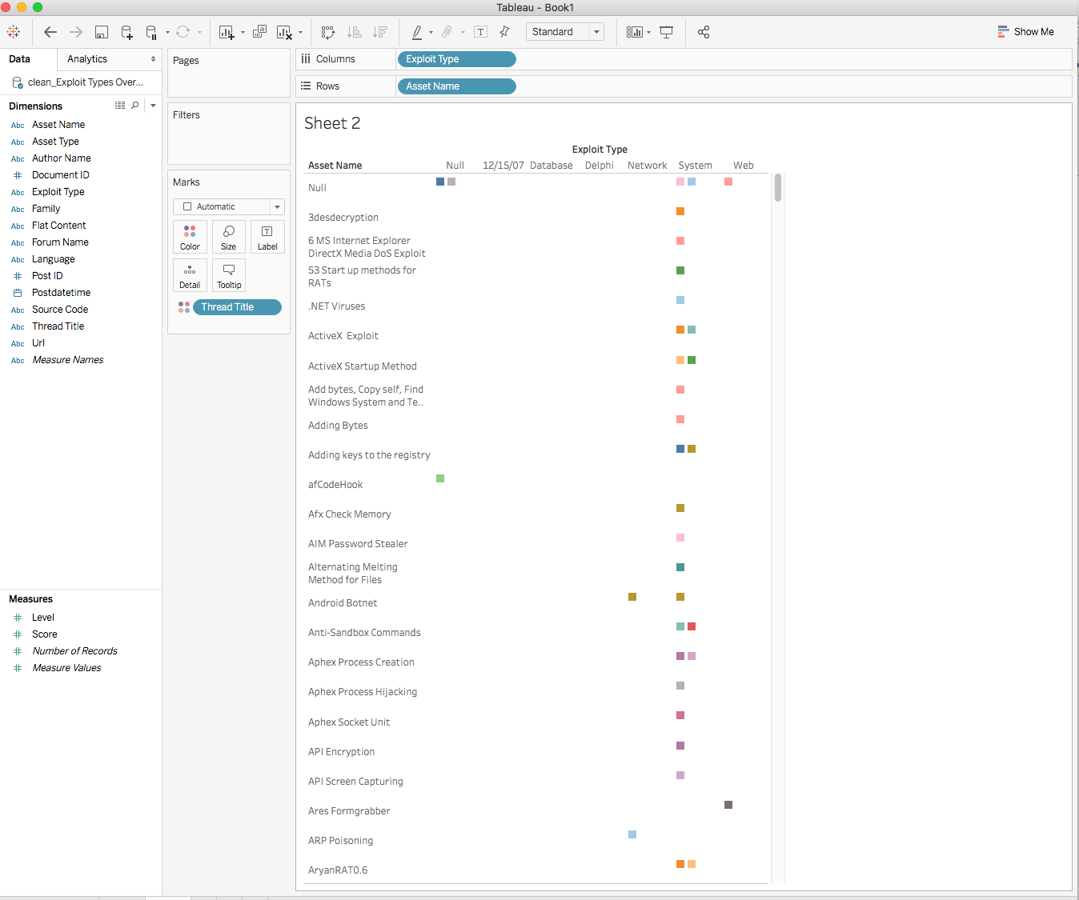

# Text based graphs

* The goal is to create a graph that shows the Authors (hackers) and how many Assets they uploaded. The following figure shows the Author names. The font size indicates the number of Assets uploaded by the hacker. The colors indicate different Exploit type.
* Select the *Author Name* dimension and drop in on the Text icon in Marks Area.
* Select the *Number of Records* variable and drop in on the Size icon in Marks Area.
* Select the *Exploit Type* measure and drop in on the Color icon in Marks Area.
* Do you expect to see repeated names? Why (not)?
* What is one way to avoid confusion by the repeated names?
* As you can see the graph is very crowded. What would you do to simplify it? Try to simplify the view by implementing your idea.

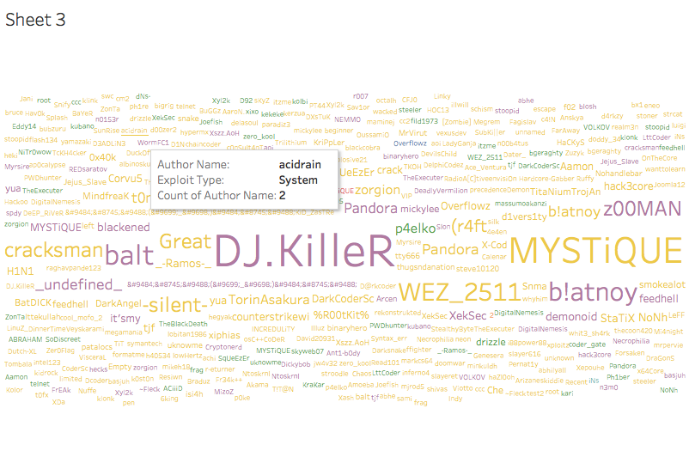

# Create Dashboard

* The goal is to bring all the three graphs created so far into a single view. Views that contain multiple graphs are called Dashboards.
* Create a new Dashboard by clicking on New Dashboard icon () at the bottom of the page .
* In the new dashboard, the right-hand side menu shows all the sheets you have created. Drag the sheets into center area. You can play with the layout to make sure the graphs are visible and the need for scrolling is minimal. You can replicate the figure below.
* Once you drag a worksheet, the filters in the sheet is carried over as well. However, they only apply to the worksheet they came with. For example, if you change the filter options for *Exploit Type,* only the line graph will be updated.
* To apply the filters to the entire dashboard, right click on the filter menus on the right and select *Apply to Worksheets > Selected Worksheets*. In the pop up menu, click on *All on dashboard*.
* Repeat the process for all the filter options.

